Chapter 1 The Database Environment and Development Process

Chapter Overview

The purpose of this chapter is to introduce students to the database approach to information systems development, the important concepts and principles of the database approach, and the database development process within the broader context of information systems development. This is an important chapter because it should convey a sense of the central importance of databases in today’s information systems environment. The idea of an organizational database is intuitively appealing to most students. However, many students will have little or no background or experience with databases. Others will have had some experience with a PC database (such as Microsoft Access), and consequently will have a limited perspective concerning an organizational approach to databases.
In this chapter we introduce the basic concepts and definitions of databases. We contrast data with information, and introduce the notion of metadata and its importance. We contrast the database approach with older file processing systems, and introduce the Pine Valley Furniture Company case to illustrate these concepts. We describe the range of database applications from personal computer databases to enterprise databases and identify key decisions that must be made for each type of database. We describe both the potential benefits and typical costs of using the database approach. We also trace the historical evolution of database systems, in order to provide a context for understanding the database approach for data storage and retrieval.
The chapter also presents an expanded description of the systems development life cycle (including an introduction to rapid application development methods of prototyping and agile software development) and the role of database development within it. The chapter provides an updated description of the well-known three-schema architecture and uses it to summarize the various deliverables of database development. The chapter concludes with an example of database development situated within the Pine Valley Furniture Company case.

Chapter Objectives

Specific student learning objectives are included at the beginning of each chapter. From an instructor’s point of view, the objectives of this chapter are to:

- Create a sense of excitement concerning the database field and the types of job opportunities that are available.
- Acquaint students with the broad spectrum of database applications and how organizations are using database applications for competitive advantage.
- Introduce the key terms and definitions that describe the database environment.
- Describe data models and how they are used to capture the nature and relationships among data.
- Describe the major components of the database environment and how these components interact with each other.
- Provide a review of systems development methodologies, particularly the systems development life cycle, prototyping, and agile software development; build an understanding of how database development fits with these methodologies.
- Develop an understanding of the different roles involved in a database development team.
- Make students aware of the three-schema architecture and its benefits for database development and design.
- Introduce the Pine Valley Furniture Company case, which is used throughout the text to illustrate important concepts.
- Introduce the Mountain View Community Hospital case, which is included at the end of each chapter as a source for student projects.

Key Terms

Agile software development | Data warehouse | Logical Schema
Client/server architecture | Database | Metadata
Computer-aided software engineering (CASE) | Database application | Physical Schema
Conceptual schema | Database management system (DBMS) | Prototyping
Constraint | Enterprise data model | Relational database
Data | Enterprise resource planning (ERP) systems | Repository
Data independence | Entity | Systems development life cycle (SDLC)
Data model | Information | User View

Classroom Ideas

- Start with a discussion of how students interact with databases on a daily basis (credit card transactions, shopping cards, telephone calls, cell phone contact lists, downloadable music, etc.). If you teach in a classroom with computers, ask students to find examples of Web sites that appear to be accessing databases.
- Contrast the terms “data” and “information”. Using Figure 1 as a starting point, have the students provide some good examples of data and information from their own experiences. This may well lead to some differences of opinion, and the conclusion that one person’s data may be another person’s information.
- Introduce the concept of metadata using Table 1. Ask the students to suggest other metadata that might be appropriate for this example.
- Discuss file processing systems and their limitations, using Figure 2 and Table 2. Emphasize that many of these systems are still in use today.
- Introduce data models using Figure 3. Discuss the differences between an enterprise data model and a project data model, using Figure 3 (a) and (b).
- Discuss each of the advantages of the database approach (Table 3). Stress that these advantages can only be achieved through strong organizational planning and commitment. Also discuss the costs and risks of the database approach (Table 4).
- Introduce the students to the major components of the database environment (Figure 5). Stress the interfaces between these components and the fact that they can “make or break” a database implementation.
- Discuss the range of database applications (personal computer to enterprise), using Figures 6 through 8 and Table 5. Ask your students to give other examples of each of these types of databases.
- Introduce the concept of a data warehouse as a type of enterprise database. This topic is described in detail in Chapter 11.
- Review the evolution of database technologies and the significance of each era (Figure 8). Add your own perspective to the directions that this field is likely to take in the future.
- Your students may have examples from their workplaces to contribute about client/server architectures. Or you may provide them with an understanding of where the DBMS software and their data will be stored at your school as an illustration.
- A quick in-class demo of Microsoft Access or similar product may be used to give the students an initial exposure to a DBMS and demonstrate a prototyping approach to database development. Consider using the PVFC prototyping request as an example.
- Discuss the role of CASE tools and a repository in information systems development. If appropriate, find out what CASE tools your students use in their work environment and their experience with these tools. If feasible, provide an in-class demonstration of a CASE tool.
- If time permits, have the students answer several problems and exercises in class.
- Use the project case to reinforce concepts discussed in class. Students can be assigned to work on this case in class if time permits, or it can be used as a homework assignment.
- If time permits, use Teradata University Network resources to demonstrate the structure and contents of a relational database for some of the textbook datasets. Demonstrate, or lead students through, some simple SQL retrieval exercises against the textbook databases.

Answers to Review Questions

1. Define each of the following key terms:
- Data. Stored representations of objects and events that have meaning and importance in the user’s environment.
- Information. Data that have been processed in such a way as to increase the knowledge of the person who uses it.
- Metadata. Data that describes the properties or characteristics of end-user data and the context of that data.
- Database application. An application program (or set of related programs) that is used to perform a series of database activities (create, read, update, and delete) on behalf of database users.
- Data warehouse. An integrated decision support database whose content is derived from the various operational databases.
- Constraint. A rule that cannot be violated by database users.
- Database. An organized collection of logically related data.
- Entity A person, place, object, event, or concept in the user environment about which the organization wishes to maintain data.
- Database management system. A software system that is used to create, maintain, and provide controlled access to user databases.
- Client/server architecture. A local area network-based environment in which database software on a server (called a database server or database engine) performs database commands sent to it from client workstations, and application programs on each client concentrate on user interface functions.
- Systems development life cycle (SDLC). A traditional methodology used to develop, maintain, and replace information systems.
- Agile software development. An approach to database and software development that emphasizes individuals and interactions over processes and tools, working software over comprehensive documentation, customer collaboration over contract negotiation, and response to change over following a plan.
- Enterprise data model. The first step in database development, in which the scope and general contents of organizational databases are specified.
- Conceptual data model (or schema). A detailed, technology-independent specification of the overall structure of organizational data.
- Logical data model (or schema). The representation of data for a particular data management technology (such as the relational model). In the case of a relational data model, elements include tables, columns, rows, primary and foreign keys, as well as constraints.
- Physical data model (or schema). A set of specifications that detail how data from a logical data model (or schema) are stored in a computer’s secondary memory for a specific database management system. There is one physical data model (or schema) for each logical data model.

2. Match the following terms and definitions:
c data
b database application
l constraint
g repository
f metadata
m data warehouse
a information
j user view
k database management system
h data independence
e database
i enterprise resource systems planning (ERP)
r systems development life cycle
o prototyping
d enterprise data model
q conceptual schema
p internal schema
n external schema

3. Contrast the following terms:
- Data dependence; data independence. With data dependence, data descriptions are included with the application programs that use the data, while with data independence the data descriptions are separated from the application programs.
- Structured data; unstructured data. Structured data refers to facts related to objects and events of importance in the user’s environment and represent the traditional data that is easily stored and retrieved in traditional databases and data warehouses. Unstructured data refers to multimedia data, such as images, sound and video segments that are now stored as part of the user’s business environment.
- Data; information. Data consist of facts, text, and other multimedia objects, while information is data that have been processed in such a way that it can increase the knowledge of the person who uses it.
- Repository; database. A repository is a centralized storehouse for all data definitions, data relationships, and other system components, while a database is an organized collection of logically related data.
- Entity; enterprise data model. An entity is an object or concept that is important to the business, while an enterprise data model is a graphical model that shows the high-level entities for the organization and the relationship among those entities.
- Data warehouse; ERP system. Both use enterprise level data. Data warehouses store historical data at a chosen level of granularity or detail, and are used for data analysis purposes, to discover relationships and correlations about customers, products, and so forth that may be used in strategic decision making. ERP systems integrate operational data at the enterprise level, integrating all facets of the business, including marketing, production, sales, and so forth.
- Two-tier databases; multi-tier databases. Both permit easier data sharing among multiple users than a PC-based database by storing the database and the DBMS on a centralized database server accessible via the network. A two-tier database houses the business logic and the user interface on the client devices. Multi-tier databases tend to house the user interface on client devices and the business logic may be maintained on multiple server layers to accomplish the business transactions requested by client devices.
- Systems development life cycle; prototyping. Both are systems development processes. The SDLC is a methodical, highly structured approach that includes many checks and balances. Consequently, the SDLC is often criticized for the length of time needed until a working system is produced, which occurs only at the end of the process. Increasingly, organizations use more rapid application development (RAD) methods, which follow an iterative process of rapidly repeating analysis, design, and implementation steps until you converge on the system the user wants. Prototyping is one of them. In prototyping, a database and its applications are iteratively refined through a close interaction of systems developers and users.
- Enterprise data model; conceptual data model. In an enterprise data model, the range and contents of the organizational databases are set. Generally, the enterprise data model represents all of the entities and relationships. The conceptual data model extends the enterprise data model further by combining all of the various user views and then representing the organizational databases using ER diagrams.
- Prototyping; Agile software development. Prototyping is a rapid application development (RAD) method where a database and its application(s) are iteratively refined through analysis, design, and implementation cycles with systems developers and end users. Agile software development is a method that shares an emphasis on iterative development with the prototyping method yet further emphasizes the people and rapidity of response in its process.

4. Five disadvantages of file processing systems:
a. Program-data dependence
b. Duplication of data
c. Limited data sharing
d. Lengthy development times
e. Excessive program maintenance

5. Nine major components in a typical database system environment:
- CASE tools: automated tools used to design databases and database applications.
- Repository: centralized storehouse of data definitions.
- Database management system (DBMS): commercial software used to define, create, maintain, and provide controlled access to the database and the repository.
- Database: organized collection of logically related data.
- Application programs: computer programs that are used to create and maintain the database.
- User interface: languages, menus, and other facilities by which users interact with the various system components.
- Data administrators: persons who are responsible for the overall information resources of an organization.
- System developers: persons such as systems analysts and programmers who design new application programs.
- End users: persons who add, delete, and modify data in the database and who request information from it.

6. Relationships between tables:
Relationships between tables are expressed by identical data values stored in the associated columns of related tables in a relational database.

7. Definition of data independence:
Data independence refers to the separation of data descriptions from the application programs that use the data. It is an important goal because it allows an organization’s data to change and evolve without changing the application programs that use the data. Additionally, data independence allows changes to application programs without requiring changes in data storage structure.

8. 10 Potential benefits:
Potential benefits of the database approach are:
- Program-data independence
- Minimal data redundancy
- Improved data consistency
- Improved data sharing
- Increased development productivity
- Enforcement standards
- Improved data quality
- Improved data accessibility and responsiveness
- Reduced program maintenance, and
- Improved decision support.

9. Five additional costs or risks of the database approach are:
- New, specialized personnel
- Installation, management cost, and complexity
- Conversion costs
- Need for explicit backup and recovery, and
- Organizational conflict.

10. Three-tiered database architecture definition:
A database architecture that allows the data for a given information system to reside in multiple locations or tiers of computers. The purpose is to balance various organizational and technical factors. Also, the processing of data may occur at different locations in order to take advantage of the processing speed, ease of use, or ease of programming on different computer platforms. Although four (and even more) tiers are possible (that is, data on a desktop or laptop microcomputer, workgroup server, department server, a corporate mainframe), three tiers are more commonly considered:
- Client tier. A desktop or laptop computer, which concentrates on managing the user-system interface and localized data—also called the presentation tier
- Department (or workgroup) minicomputer server tier. Performs calculations and provides access to data shared within the workgroup—also called the process services tier
- Enterprise server (minicomputer or mainframe) tier. Performs sophisticated calculations and manages the merging of data from multiple sources across the organization—also called the data services tier

11. Possibility of no database on a tier of 3-tiered database?
Yes, it is possible. The end user machine (in the client tier) — a PC, for example — might have presentation logic but no database installed on it.

12. Five SDLC phases:
- Planning
Purpose: To develop a preliminary understanding of the business situation and how information systems might help solve a problem or make an opportunity possible Deliverable: A written request to study the possible changes to an existing system; the development of a new system that addresses an information systems solution to the business problems or opportunities
- Analysis
Purpose: To analyze the business situation thoroughly to determine requirements, to structure those requirements, and to select among competing system features
Deliverables: The functional specifications for a system that meets user requirements and is feasible to develop and implement
- Design
Purpose: To elicit and structure all information requirements; to develop all technology and organizational specifications
Deliverables: Detailed functional specifications of all data, forms, reports, displays, and processing rules; program and database structures, technology purchases, physical site plans, and organizational redesigns
- Implementation
Purpose: To write programs, build data files, test and install the new system, train users, and finalize documentation
Deliverables: Programs that work accurately and according to specifications, documentation, and training materials
- Maintenance
Purpose: To monitor the operation and usefulness of a system; to repair and enhance the system
Deliverables: Periodic audits of the system to demonstrate whether the system is accurate and still meets needs

13. Activities and five phases of SDLC?
Database development activities occur in every phase of the SDLC. Actual database development is most intense in the design, implementation, and maintenance steps of the SDLC.

14. Commonalities of SDLC, prototyping, agile development methodologies:
Procedures and processes that are common to SDLC, prototyping, and agile methodologies include:
- Understanding and analyzing the customer’s business requirements for the system
- Translating the customer’s requirements into specifications (logical & physical) for systems development
- Developing databases and software programs to meet specifications; and
- Implementing an operational system.

The methodologies are considered to be different not because of what is done, but because the timing of the methodologies differ. The SDLC methodology is methodical and thorough which makes it well-suited for systems that populate and revise databases. Prototyping, with its rapidly repeating analysis, design, and implementation phases, is well-suited for systems that retrieve data and for helping to refine a customer’s requirements for a new system. Agile software development emphasizes quick responses and rests on high-involvement from knowledgeable customers. Agile software development is well-suited to projects with unpredictable and/or rapidly changing requirements and responsible developers (per text citation of Fowler, 2005).

15. Differences between conceptual schema, user view, and internal schema:
A conceptual schema defines the whole database without reference to how data are stored in a computer’s secondary memory. A user view (or external schema) is also independent of database technology, but typically contains a subset of the associated conceptual schema, relevant to a particular user or group of users (e.g., an inventory manager or accounts receivable department). An internal schema consists of both a physical schema and a logical schema. A logical schema consists of a representation of the data for a type of data management technology. For example, if the relational model is the technology used, then the logical schema will consist of tables, columns, rows, primary keys, foreign keys and constraints. A physical schema contains the specifications for how data from a logical schema are stored in a computer’s secondary memory.

16. Three-schema architecture:
a. external schema
b. conceptual schema
c. internal schema

- Phases and activities of SDLC within textbook scenario:

Student answers may vary depending upon whether or not they read the section closely enough to realize that Chris is following a prototyping methodology approach to developing the database application for PVFC. The prototyping methodology is shown in Figure 8, while the traditional development approach is shown in Figure 7.

According to Figure 8, Chris’ project activities would map to the following phases of the prototyping database development process:

Chris’ activities | Prototype phase (and comments)
Project Planning | Identify Problem (Conceptual Data Modeling)  - To some extent, a separate “planning” phase does not really exist under the prototyping approach as it happens continuously as the prototype evolves. On the other hand, the Identify Problem phase involves sketching a preliminary data model, which is work that Chris clearly completes.
Analyzing Database Requirements | Identify Problem (Conceptual Data Modeling)  Develop initial prototype (Logical Database Design)  - In this stage of Chris’ work with Helen, he is still gathering iterations of the kinds of data that Helen needs to do her job. In some ways, Chris is refining the Conceptual Data Model and in other ways Chris is developing the more detailed Logical Database Design.
Designing the Database | Develop initial prototype (Logical Database Design, Physical database design and definition, database implementation)  - Chris takes the knowledge he has gained from the initial sessions with Helen and begins to build a functioning example of the database in an agreed-upon relational database management system.
Using the Database | Implement and use prototype; Revise and enhance prototype (Database maintenance)  - Chris provided enough of a working sample database that Helen could use it and make suggestions about how to revise it. Chris could iteratively make changes to improve the solution, and move some initial ad-hoc queries into more formal reports.
Administering the database | Convert to operational system (Database maintenance)  - Chris and Helen agreed that the prototype was functioning efficiently enough to allow it to become the everyday, operational, “production” system for Helen to use. As requested by Helen, and when time allows, Chris is able to make changes to the operational database to better meet Helen’s needs and requests.

18. Why does PVFC need a data warehouse?
Pine Valley Furniture Company (PVFC) uses a database management system to support its operational functions but this database is not structured in a way that supports timely analysis of trends or historical patterns. PVFC can benefit from a data warehouse that is appropriately structured for questions related to vendor pricing and/or customer order patterns over time. A data warehouse would enable PVFC to summarize data drawn from various operational databases (i.e., personal, workgroup, department, and ERP) into meaningful structures for timely decision-making access.

19. Three areas where very large databases are used:
Very large databases are being used to improve customer relationship management (CRM) by creating CRM systems that react to individual customer’s purchase behavior. For example by suggesting other items that a customer may want to purchase based on that customer’s previous purchases. They are also being used to improve employee relationship management by tracking employee skills and sending notice when an internal job opportunity that needs a particular skill that the employee possesses is announced. Online shopping sites are able to carry a large virtual inventory stored in a database for the customer to peruse.

Solutions to Problems and Exercises

1. Examples of relationships:
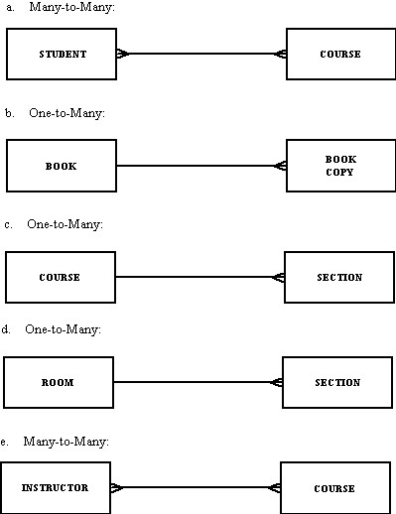

2. Advanced data types have several special requirements:
- Storage requirements – multimedia objects (such as images, sound, and video clips) require substantial storage capacity, which needs to be justified.
- Content management – this is the problem of storing, locating, and retrieving the multimedia objects. This process requires specialized software not generally available in a relational DBMS or extra effort to create a means to rapidly access multimedia objects (such as keyword indexes).
- Maintenance – while conventional relational data are easily updated, multimedia objects may require maintaining multiple versions of the data. Usually the whole object needs to be restored because it is treated as a whole rather than a set of parts.

3. Metadata for Class Roster:
Please note that some columns have been omitted in order to save space. Columns “Created”, “Updated”, and “Responsible Party” were added to the Metadata.

Name | Type | Description | Source | Created | Updated | Responsible Party
Course | Alphanumeric | Course ID and name | Academic Unit | 5/10/2012 | 6/1/2012 | Registrar
Section | Integer | Section number | Registrar | 5/10/2012 |  | Registrar
Semester | Alphanumeric | Semester and year | Registrar | 5/10/2012 |  | Registrar
Name | Alphanumeric | Student name | Student IS | 8/07/2011 |  | Student IS
ID | Integer | Student ID (SSN) | Student IS | 8/07/2011 |  | Student IS
Major | Alphanumeric | Student major | Student IS | 8/07/2011 | 11/15/2011 | Student IS
GPA | Decimal | Student grade point average | Academic Unit | 8/07/2011 | 5/10/2012 | Department Chair

4. Why do organizations create multiple databases?
There are several reasons. First, because of resource limitations, organizations fund development of their information systems one application at a time. Second, organizations may acquire some of their information systems from outside vendors. This also results in a proliferation of databases. Third, mergers and acquisitions generally result in multiple databases.
What organizational and personal factors lead an organization to have multiple, independently managed databases?
Perhaps the most common reason is that end-user groups develop their own database applications, rather than wait for the central IS organization to develop a centralized database. Also the pressures associated with rapid business change result in organizations taking a short-term, suboptimal approach rather than a careful, long-term strategy.

5. Data entities and Enterprise Data Model for student organization or group:
This is a good in-class, interactive exercise for individuals or small groups. For individuals, have each student choose a student club, fraternity/sorority, or other organization to illustrate a “top-down” approach to develop an enterprise data model. For small groups, divide the class into groups and have each group work to develop an enterprise data model for a club, fraternity/sorority, or other organization. Reconvene as a large class to compare/contrast each of the small group enterprise data models. Identify the similarities and differences through class discussion.

6. Data from driver’s license bureau:
  - Driver’s name, address, and birthdate: structured data
  - The fact that the driver’s name is a 30-character field: metadata; fact describing property
  - A photo image of the driver: unstructured data
  - An image of the driver’s fingerprint: unstructured data
  - The make and serial number of the scanning device that was used to scan the fingerprint: structured data
  - The resolution (in megapixels) of the camera that was used to photograph the driver: metadata; fact describing context
  - The fact that the driver’s birth date must precede today’s date by at least 16 years: metadata; fact describing context

7. Great Lakes Insurance database suggestion:
One suggested approach would be to create an enterprise database to contain all information about customers, policies, etc. The need for an enterprise database is clear, since policy information would need to be accessed not just by the sales team but also by the actuarial department and the claims department. For inside agents, access to the database would be through an intranet, utilizing a browser-based application as the front-end. Each outside agent would have a personal database on his or her notebook computer with only information for his or her territory. The personal database would then be synchronized periodically with the enterprise database through the use of an extranet.

8. Pet Store data model questions:
  - one-to-many
  - one-to-many
  - There could be a relationship between customer and store. (It would be useful if the customer had never purchased a pet, so for example the store could send mailings to prospective customers.)

9. Questions about Figure 12 database:
Some common data elements that may be redundant are: Vendor ID, Vendor Name, Vendor Address, Customer ID, Customer Last Name, Customer First Name, Customer Middle Initial, Purchase Order Number, Purchase Order Date.

Problems that could arise because of this duplication are that payments may not be properly matched to vendor orders, or that customer receipts are improperly matched to customer bills. These potential mismatches could cause issues in collection and payment of financial transactions for the organization, and may cause issues with relationships with customers and vendors.

At a first glance, these duplications appear to violate the principles of the database approach outlined in this chapter. However, the organization may have procedural or system checks-and-balances that periodically audit or synchronize the apparent data duplication throughout the organization in this three-tier scenario. These checks-and-balances are not apparent on this Figure, and might compensate for the apparent violation of database approach principles.

10. Representation of SDLC:
The representation of the systems development life cycle has changed from the original waterfall metaphor. While it is a more compact representation, there are still some problems. For example, it is not purely linear. Also, it is possible to conduct steps in parallel due to time overlaps. One additional problem is the inability to go back from one step to another without completing the entire five-step process

11. Three additional entities for PVFC: EMPLOYEE, SUPPLIER, and SHIPMENT might be good examples since all of them represent major categories of data about the entities managed by the organization

12. Consider Business Enterprise example:
a. Enterprise Data Model
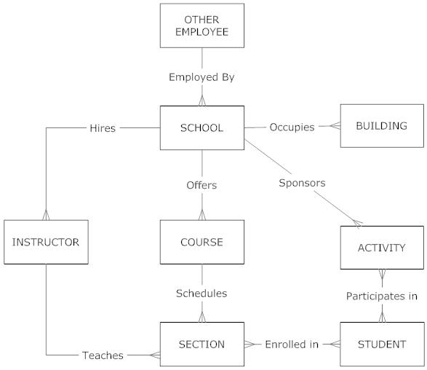

b. Benefits from a multiple-tiered architecture for data?

Considerations for using a multi-tier architecture: Since much of the data may be updated from a large number of different functions, network traffic will be an issue of crucial importance. Processing close to the source data could reduce network traffic. Client technologies however, can be mixed (personal computers with Intel or Motorola processors, network computers, information kiosks, etc.) and yet, share common data. In addition, you can change technologies at any tier with limited impact on the system modules on other tiers. All this will allow for data consistency and maintaining academic standards — a critical success factor for the academic unit.

13. Contrasting database development during conceptual data modeling and logical database design phases:

It is often said that conceptual data modeling is done in a top-down fashion, driven from a general understanding of the business area, not from specific information processing activities. Logical database design approaches database development from two perspectives. First, the conceptual data model is transformed into a standard notation through normalization, based on relational database theory. Then, as each computer program in the information system is designed — including the program’s input and output formats — a detailed review of the transactions, reports, displays, and inquiries supported by the database is performed. This bottom-up analysis verifies exactly what data are to be maintained in the database and the nature of those data as needed for each transaction, report, and so forth. During logical database design, you combine or integrate the original conceptual data model (more general information) along with the individual user views (more specific information) into a comprehensive design.

14. Location of prototype database:
Department databases are often developed in combination by end users, systems professionals working in business units, and central database professionals. A combination of people is necessary since a wide variety of issues must be balanced in the design of shared databases: processing speed, ease of use, differences in data definitions, and the like. Often, the prototype being developed will be located on a development area server, where those involved with the project will have easy access to the database and no likelihood of interfering with the organization’s production databases. This answer assumes that the organization maintains a development and production server for the databases.

15. Enterprise data models and conceptual data models:
Enterprise data modeling results in a total picture or explanation of organizational data, not in the design for a particular database. A particular database provides the data for one or more information systems, whereas an enterprise data model, which may encompass many databases, describes the scope of data maintained by the organization. Therefore, the level of abstraction associated with an enterprise data model is higher; conceptual data models will be more detailed.

16. Iteration between physical and logical database design:
Database development activities occur in each of the SDLC phases, and feedback may occur which causes a project to return to a prior phase. SDLC activities may find missing elements or errors when designing specific transactions, reports, displays, and inquiries. When a missing element is noticed, for example, it is necessary to revisit the logical database design.

17. User views of organizational data:
A good approach in developing this problem for a bank might be to carefully select the views to be developed by collecting a transaction slip, monthly statement (representing each type of account), statement of earnings, etc. Examples of data included in each message are customer information, bank information, and transaction data (checks, deposits, service charges, maintenance fees, overdraft protection fees, and so forth). Statement and deposit slip views are given below, as is the combined conceptual data model. Combining the different views could lead to the addition of new attributes or possibly entities and relationships not being shown in the original views.

Statement view:
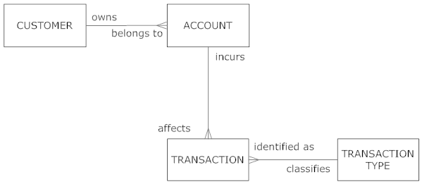

Deposit slip view:
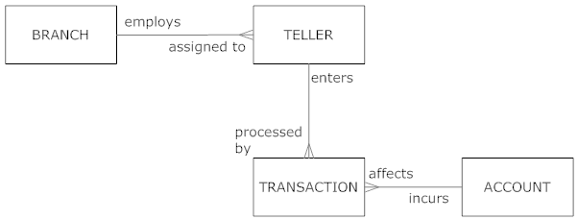

Conceptual Data Model:
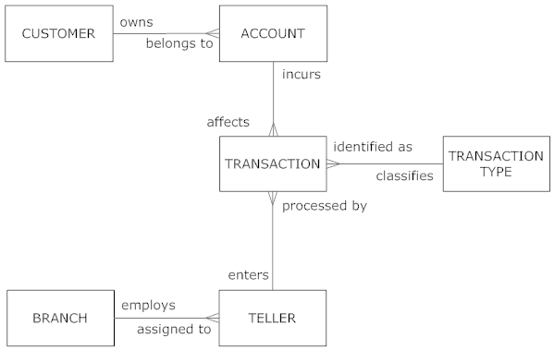

18. Explain Figure 15:
The single line connection indicates a one-to-one relationship between the entities. In business terms: each order is billed on exactly one invoice, each invoice is written for only one order. In contrast, many payments can be made on one order. Remember to model for the exceptions.

19. Questions about Project Data Model in Figure 15:

- A Customer places many orders, yet an Order is placed by one Customer. Each Order is billed on a single Invoice and an Invoice is related to a single Order. Each Payment is related to a single Invoice, but an Invoice may be paid with one or several Payments. Each Order contains multiple Order Lines but a specific Order Line refers to only one Order and one Product at a time. Each Product may be seen on multiple Order Lines. Each Product belongs to only one Product Line and a Product Line includes multiple Products. For each Customer, PVFC tracks the ID, Name, Type, Zip Code and number of years it has been a PVFC customer. For Orders, we track Order number along with each order’s placement date, fulfillment date, and number of shipments. For Invoices, we track Invoice number, Order number, and Invoice Date. Each Payment tracks the Invoice Number, Payment Date, and Payment Amount. Each Order Line tracks the specific quantity of product for the specific order. For Products, we track its ID, description, finish, standard price, product cost, prior year’s sale goal, and current year’s sale goal. Each Product Line tracks its name, prior year’s sales goal and current year’s sale goal.
- The aspect of the diagram that is difficult to describe (and may also be difficult to implement and maintain) is the sales goal attributes for the Product Lines and Products. Since it is expressed as Prior Year and Current Year values, this data will need to be maintained with additional programming in the database application, as there is currently no logical design to deal with this time-based data in the proposed design. In my opinion, the reason for this ambiguity is that the prototyping approach did not yet experience the maintenance issues of date-related data in the database, due to the shortened time working with the data and sample reports. As the end user and the analyst works through the database application over a year or so, this situation will become painfully in need of an adjusted design and will likely become a less ambiguous requirement.

20. SQL statements in Figure 17 and 18 questions:
- The field size for the ProductLineName field in the Product table may be 1-40 characters. This size is due to the SQL Create Table definition of ProductLineID field being set to 40 characters, with a VARCHAR datatype.
- The ProductID field is specified as NOT NULL in the SQL statement. ProductID is a required attribute because it is designed as the Primary Key of the table, and in relational design Primary Key fields cannot be empty or missing.
- The FOREIGN KEY clause in the SQL statement tells us that the ProductLineID field in the Product_T table refers back to the ProductLineID primary key that is stored in the ProductLine_T table. This FOREIGN KEY clause is the way that referential integrity in a relational database is enforced in the actual physical database.

21. SQL Query in Figure 19:
- Sales to Date is calculated by multiplying the quantity by the price.
- Eliminating “Home Office” from the Criteria line under ProductLineName would result in all product line names being displayed, not just the Home Office line.

22. Figure 15 and new Query specification questions:
    - The following entities will be needed: Payment, Invoice, Order, Order Line, Product, Customer
b. All of the above entities will be needed for the SQL query.

23. Summary of important properties of data models:

 | All Entities? | All Attributes? | Technology  Independent? | DBMS Independent? | Record Layouts?
Enterprise | Y | N | Y | Y | N
Conceptual | Y | Y | Y | Y | N
Logical | Y | Y | N | Y | Y
Physical | Y | Y | N | N | Y

Suggestions for Field Exercises

- You can accomplish this exercise either by arranging a field trip for your class (preferred), or by inviting the IS manager (or other key IS person) to visit your class. Following are some of the key steps to perform:
- Select an organization. We suggest a mid-sized manufacturing company or a familiar organization in the service sector such as a hospital or bank.
- Identify several mainstream applications such as human resource management, material requirements planning, and financial accounting.
- Determine whether these applications were predominantly developed internally, or purchased from an outside vendor or vendors.
- Now determine the mix between file processing and database processing for these applications. If a database approach is used, is the data shared among the applications?
- To draw a figure depicting the files and databases, inquire whether the organization has system flowcharts (or similar documentation) that portray much of this information.

- This exercise is most easily performed as a continuation of Exercise 1. Arrange to interview a database administrator or key designer as part of the same field trip. Discuss whether the organization maintains user-oriented metadata, or only technical metadata. Where is this metadata maintained: within individual applications, in one or more CASE tool repositories, or elsewhere?

- If the student has selected an established company with a fairly extensive information systems department, they will find that the company is either already very involved in Web-enabling some or many parts of their business, or that they are actively planning to expand the scope of their involvement. You may want to encourage your students to use this question to explore where the company sees itself going with regard to the Internet. Many older companies are struggling very hard to adjust and remain competitive as the Internet dramatically affects business models.

- Again, as in the previous field exercise, this exercise will help students to integrate their new textbook knowledge with the realities that organizations must face. Some students will find organizations that are struggling to achieve client/server architecture and also deal with their legacy systems, for example.

- Students will probably find prototyping being used for smaller database applications. Prototyping is often the systems development methodology of choice where visual programming tools such as Visual Basic, Java, Visual C++, and fourth-generation languages are used because of the ease with which the user-system interface can be modified. Large systems that require a new database are more likely to use the SDLC, requiring a team of information systems professionals, including database designers and programmers. The systems development process for Web applications can be similar, with prototyping being employed. However, students may find that there is a lot more testing involved with Web applications, since one has less control over the client interface.

- Students are likely to find some of the following roles on the information systems development teams in larger organizations:
- Systems analysts, who analyze the business situation and identify the need for information and information services to meet the problems or opportunities of the business
- Database analysts, who concentrate on determining the requirements and design for the database component of the information system
- Users, who provide assessment of their information needs and monitor appropriateness of the developed system
- Programmers, who design and write computer programs that have embedded in them commands to maintain and access data in the database
- Database and data administrators, who have responsibility for existing and future databases and ensure consistency and integrity across databases; as experts on database technology, they provide consulting and training to other project team members
- Other technical experts, with facility in networking, operating systems, testing, and documentation
- A senior systems or database analyst, who will be assigned to be project leader, who is responsible for creating detailed project plans as well as staffing and supervising the project team; this good project leader will possess leadership, management, customer relations and communications, technical problem solving, conflict management, team building, and risk and change management skills.

In smaller organizations, students may find that these roles are combined and performed by fewer people because the smaller organizations do not have the additional staff to assign to a diverse team. Thus, fewer people will cover these same functional responsibilities by each person having multiple roles to fulfill. Many employees in small organizations develop deep skill sets in programming, data administration, or technical database administration expertise.

- Note: See chapter section on “Managing the people involved in database development” for more background on this exercise.

If a CASE tool is being used, a repository stores descriptions of the data entities and the business rules, detailed descriptions of CSFs, and objectives. The information systems department analyzes all of them. Throughout the systems development process, CASE tools are used to develop data models and to maintain (in the repository) the metadata for the database and applications. A repository maintains all of the documentation too. Various people might use the CASE tools and associated repository during a database development project: systems analysts, database analysts, users, programmers, database and data administrators, and other technical specialists. As a significant new portion of a project is completed and entries are made in the repository, a review point occurs so that those working on the project and funding the human and capital resources of the project can assess progress and renew commitment based on incremental achievements.

- Student answers will vary depending upon the organization and the functional area chosen for the interview. As long as students are encouraged to contact individuals in larger or corporate environments, answers should reflect a variety of approaches to retrieving data, kinds of systems accessed for data retrieval, frequencies of data retrieval, levels of satisfaction with data access and retrieval, and challenges experienced. This would be a good exercise to assign for out-of-class investigation, and then use in-class time for students to meet in small groups to share their results with one another. A subsequent large-group discussion led by the instructor can readily illustrate the different experiences and raise student awareness of the diversity in organizational approaches to data storage, access, and retrieval.

- Student answers will vary.

Project Case
Case Questions

1. A well-managed database might help the hospital achieve its mission by:
- Tracking operating costs, and identifying costs that are rising or are above average for similar hospitals.
- Providing an electronic medical record for each patient, so that physicians can quickly assemble all relevant information.
- Developing historical records of various treatment programs, to identify which programs and procedures are most effective (and which are not).
- Providing data and information to track important measures such as average length of patient stay, cost per day for a patient, and so on.

2. Database technology can provide several mechanisms to ensure that data are protected and that the hospital conforms to HIPAA standards. The following table is taken from the standards and highlights some areas that database technology can help with regarding compliance.

Standards | Implementation Specifications
Security and Training | Login Monitoring  Password Management
Contingency Plan | Data Backup Plan
Device and Media Controls | Data Backup and Storage
Access Control | Encryption
Transmission Security | Encryption

3. Some of the costs and risks of using databases that the hospital must manage carefully are:
- New, specialized personnel. This will include database designers, database administrators, and other skills that are in short supply in a tight job market.
- Installation and management cost and complexity. This may include installing a new DBMS as well as hardware and operating system upgrades.
- Conversion costs. These are primarily the costs of converting older applications to a database environment. Alternatively, the hospital may choose to purchase new systems from a vendor.
- Need for explicit backup and recovery. These are the system costs associated with backup and recovery procedures.
- Organizational conflict. The hospital must anticipate the costs of data administration and other activities related to developing a consensus on data definitions, ownership, and maintenance.

4. Data quality is of utmost importance in a hospital environment. This is particularly true when considering applications such as patient care administration and clinical services, since poor data quality could directly affect patient care. Less critical, but still important, is data quality for financial management and administrative services.

5. There are several complex data types that must be managed by a hospital:
- Medical scans (MRI, X-ray, etc.)
- Clinical test data (blood test, etc.)
- Documents (admission forms, physician referrals, etc.)
- Unstructured text (doctors’ orders, doctors’ notes, etc.)
- Test results (electrocardiograms, ultrasound, etc.)

6. Mountain View Community Hospital could use Web-based applications in several ways. Perhaps one of the greatest areas that it could use this technology would be to establish an Intranet for access to databases by internal hospital personnel. Also, the hospital could investigate an extranet application to do third-party billing directly with insurance companies. Another application would be to enable access to medical databases and prescription drug databases that are available online. Web-based applications have several benefits, including streamlining such processes as third-party billing. One major risk associated with any Web-based application is security. Even having data available via an Intranet could still pose a security risk to the hospital if network security did not prevent unauthorized access from the outside.

7.
- Each WARD has any number of PATIENTs assigned to it.
- A SUPPLY ITEM may be provided by any number of VENDORs.
- A MEDICAL/SURGICAL ITEM may be used by one or many PATIENTs.

Case Exercises

1a. Relationship between PATIENT and PATIENT CHARGES:



1b. Metadata chart:

Data Item Value

Name | Type | Length | Min | Max | Description
Patient Name | Character | 30 | __ | __ | Patient’s name
Patient Number | Integer | 4 | 0000 | 9999 | Patient ID
Patient Address | Character | 40 | __ | __ | Street/City/State/Zip
Item Description | Character | 20 | __ | __ | Item name
Item Code | Integer | 3 | 00 | 999 | Item ID
Amount | Decimal | 7 | 0.0 | 99,999.99 | Amount charged

Note: Student answers may vary as there are many other attributes that could be listed in this solution.

2a. Patient Bill view:

Patient Name: Dolan, Mark
Patient Number: 4238
Patient Address: 818 River Run

Item Code Item Description Amount
200 Room Semi-Priv 1600
275 Radiology 150
700 EEG Test 200

2b. We will have to first take a look at the Data Item/Name column of the metadata chart. It does list data items in the form of entity attributes’ names. Since the preliminary enterprise data model will not show data attributes, but entities only, we could only verify if a particular entity from the metadata chart is represented on the enterprise data model; no detailed verification can be performed. Also, Item Code and Item Description that appear on the patient bill are not sufficient to determine whether a MEDICAL/SURGICAL ITEM or a SUPPLY ITEM is taken into consideration, e.g., some entity data may be similar in nature to other entity data. We need to go back and re-label the attributes in order to avoid misinterpretation.

3. E-R diagram (simplified) for hospital:

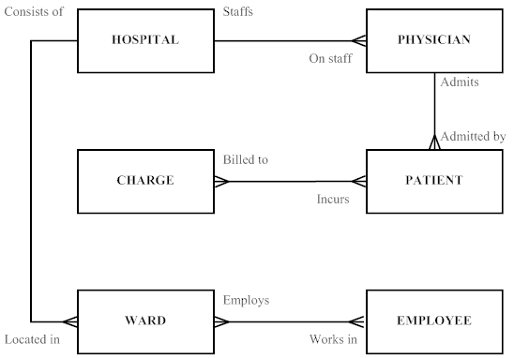

4a.
Name | Type | Length | Min | Max | Description | Source
Employee ID | Integer | 4 | 1 | 9999 | Employee ID | Human  Resources
Date Hired | Date | 8 |  |  | Date of Hire | Human Resources
Employee Type | Text | 15 |  |  | Type of Employee | Human Resources

4b. 1:M Physician to Patient
M:M Patient to Charge

The simplified ER diagram completed for exercise 3 suggests these relationships.

4c. The Patient table will contain information about a patient, such as Patient ID, Patient Last Name, Patient First Name, and Patient Middle Initial. The Patient table is likely to have stored the Physician ID value for the physician who admitted the patient. In order for this data to be useful for human interpretation, one would need to be able to link the Patient table with other tables, such as the Physician table, Charge table, etc.

4d. A sample report might look like the following:

Mountain View Community Hospital
Daily Inpatient Roster
Date: March 1, 2006

Patient Name Physician Admit Date Care Center Room
Terri Smith Larry Moxley Feb. 24, 2006 Cancer Care Center 100
Chris Bailey Larry Moxley Mar 1, 2006 General Care Center 102

Total Patients: 2

5. SELECT *
FROM Patient
WHERE PatientLastName > ‘A’;

6. Given the high priority assigned to this project, the obvious strategy is to first determine whether packaged information systems (including associated packaged data models) are available for risk management. Most hospitals are facing the same problems, and it is very likely that hospital-specific data models and systems are available. Of course, the hospital staff will have to determine whether such systems meet their needs and are compatible with existing development efforts. If instead, Mountain View Community Hospital decides to develop the systems internally, the solution could be a combination of the prototyping and life cycle approaches. Once the enterprise model has been agreed upon, it should be possible to identify the entities and relationships involved in the desired risk management system. From there, an interim prototype of the risk management system could be built if the manager’s needs are deemed to be so critical that such a step is necessary. Thus, project initiation and planning (including placing this project within the company’s information system architecture) can be addressed quickly. Then developers can use an iterative cycle of analysis, design, and implementation to work closely with the manager of the risk management area to develop a working prototype of the system he or she needs. This system probably needs a database of limited scope, which may be used until it is integrated into the completed system.

7. Since we have considered prototyping the system as a preliminary piece of the entire system, but one that will be used quickly, this system may well be developed as a stand-alone database. Then, the unstructured and unpredictable use of data will not interfere with access to the operational databases needed to support efficient transaction processing systems. Also, the confidential information will not need to travel across the network, where possibilities of interception exist.

Project Assignments

P1. It sounds as if the team should be ready to consider the requirements of the proposed expansion of the system to possibly handle the two proposed new departments, Retirement Living and Geriatric Medicine. These requirements will need to be integrated into the existing enterprise model. Once the entire enterprise model is constructed, the proposed subsystems should be identified and prioritized so that plans can be laid to move on to begin the conceptual data model.

P2. Some other views could be:
Treatment View – what patients received which treatments
Physician View – what patients were treated and/or admitted by which physicians
Laboratory View – which patients were tested
Pharmacy View – what drugs were prescribed to which patients
Nurse_Supervisor View – how are patients assigned to nurses
Care Center View – which patients are in a particular care center; what staff have been assigned to the care center
Lab Supervisor View – which technicians performed certain tests

P3.
a. Note: Based on a reading of the Case Scenario, the clearly stated business rules tend to support the preliminary enterprise data model as shown in Case Exercise 3 solution above; no modifications are necessary based on the stated business rules. However, a thorough reading of the Case Scenario will reveal the importance of Volunteers as well as a need to include Risk Management issues in this proposed new system and database. One of the events that a Hospital such as this may need to address is the use of an Evacuation Location. Thus, it can be implied that additions of Evacuation Location and Volunteer entities to the enterprise data model would be useful to development efforts of the project team (see revised diagram below). Adding these entities now will assist the team in remembering that the new system may require more data to support the requirements from these areas as the project progresses.

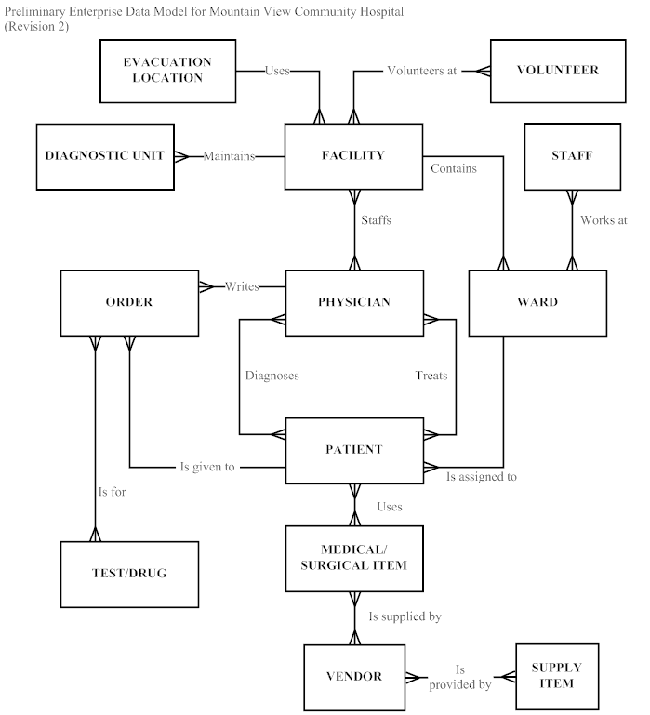

b.
A volunteer volunteers at 1 or more facilities.
A facility has 1 or more volunteers.
A facility uses 1 evacuation location.
An evacuation location is used by many facilities.

c. MVCH Context Diagram

